Assignment : 2

Draw a diagram of the OSI 7-layer model and label each layer with its correct name and a real-world example of a device or protocol that operates at that layer (e.g., Switch at Data Link, HTTP at Application).
Ans :
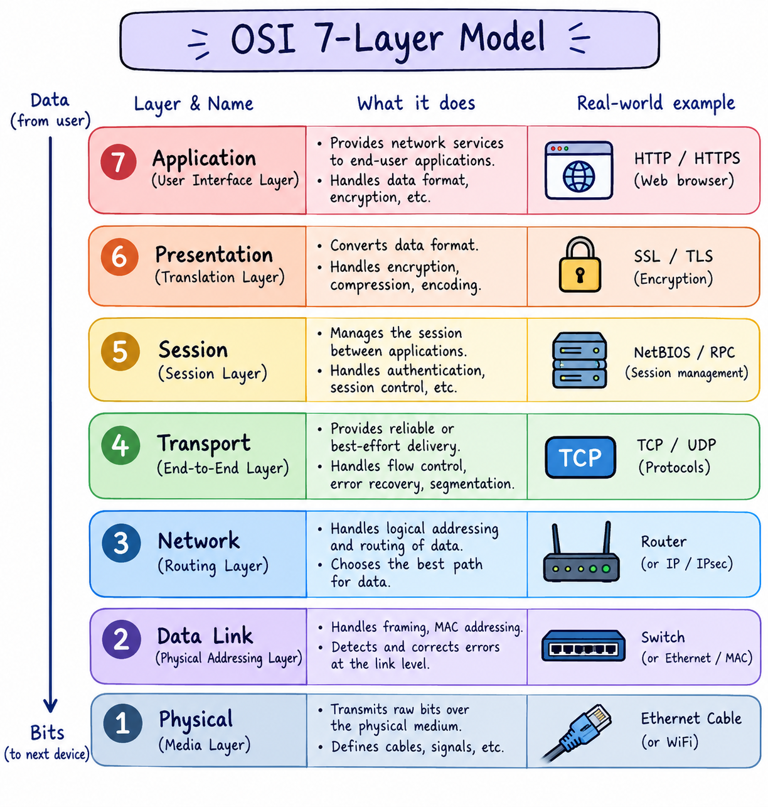

Match the following networking scenarios to the correct OSI layer: a) Encrypting data before sending, b) Routing packets across networks, c) Converting data to electrical signals, d) Opening a web page in your browser, e) Detecting and correcting errors in frames.<br><br><em><strong>Hint:</strong> Write your answers as 'Scenario: Layer Name (Layer Number)'.</em>
Ans :
a) Encrypting data before sending: Presentation Layer (Layer 6)
b) Routing packets across networks: Network Layer (Layer 3)
c) Converting data to electrical signals: Physical Layer (Layer 1)
d) Opening a web page in your browser: Application Layer (Layer 7)
e) Detecting and correcting errors in frames: Data Link Layer (Layer 2)

Pick any app you use daily (like WhatsApp, Instagram, or Zomato) and describe how at least three different OSI layers are involved when you send or receive data in that app.
Ans :
Example: WhatsApp
- Application Layer (Layer 7): When I send a message, WhatsApp prepares the data for sending.
- Transport Layer (Layer 4): TCP/UDP helps deliver the data between my phone and the WhatsApp server.
- Network Layer (Layer 3): IP addresses and routers help the data travel across networks to the server.
- Data Link Layer (Layer 2): WiFi or Ethernet carries the data between my phone and the router.
- Physical Layer (Layer 1): Radio signals or cables transmit the data as electrical or wireless signals.

Given this scenario: You are unable to access a website, but you can successfully ping its IP address. Identify which OSI layer(s) might be causing the problem and explain your reasoning.
Ans :
If I can ping a website’s IP address but cannot open the website, the problem is likely at the Transport Layer (Layer 4) or Application Layer (Layer 7).
- Network Layer (Layer 3): Working, because ping confirms that packets can reach the IP address and return.
- Transport Layer (Layer 4): May have a problem if TCP port 80 (HTTP) or 443 (HTTPS) is blocked or the web server is not accepting connections.
- Application Layer (Layer 7): May have a problem if the web server is down, the website is not responding, or the browser cannot load the page.
Example: I can ping 142.250.183.14, but the website does not open. This means the network path is working, but the web service or its connection may be failing.

